Project Report
Script-Controlled Record Access in ServiceNow

Script-Controlled ACL – Restrict Record Access Based on Field Value

Team ID | SWTID-2026-9989
Date | 25 September 2026
Platform | ServiceNow (Personal Developer Instance)
GitHub | https://github.com/dkarthik7237/script-acl.git
Team Members | 1. Bommanasamy S  2. Boopathi S  3. Dharshan P  4. Dheepak Karthik S  5. Dineshkumar A

Table of Contents
1. Introduction
2. Ideation Phase
3. Requirement Analysis
4. Project Design
5. Project Planning&Scheduling
6. Functional and Performance Testing
7. Results
8. Advantages&Disadvantages
9. Conclusion
10. Future Scope
11. Appendix

1. Introduction

1.1 Project Overview
In many organisations the same table holds both ordinary and highly sensitive records. A normal role-based Access Control List (ACL) in ServiceNow decides access for the whole table, so anyone who holds the table role can open every record. This project, Script-Controlled ACL – Restrict Record Access Based on Field Value, solves that gap. A custom table (Secure Records) carries a Classification field (Public, Internal, Confidential). Script-controlled ACLs read the Classification of each record and allow Confidential records only for the u_confidential_viewer role, administrators and the record owner.
The solution is built entirely with native ServiceNow features on a Personal Developer Instance, and is verified with Impersonate User, Security Debugger and the REST Table API. Source and Update Set are kept in GitHub: https://github.com/dkarthik7237/script-acl.git

1.2 Purpose
- Protect sensitive records individually, based on the value stored in a field.
- Show how an ACL script can make a record-level allow / deny decision.
- Give one reusable pattern that works on list views, forms, reports and REST calls.
- Document, test and hand over the solution in a repeatable way.

1.3 Team Members
S.No | Team Member | Main contribution (from sprint allocation)
1 | Bommanasamy S | Write / create ACL, standard-user list-view scenario
2 | Boopathi S | Role and test-user setup, confidential-viewer scenario
3 | Dharshan P | Delete restriction, owner scenario, reclassification testing
4 | Dheepak Karthik S | Table and field creation, script-controlled read ACL, Update Set export and GitHub repository
5 | Dineshkumar A | Sample data entry, Security Debugger, direct-link scenario, UAT

2. Ideation Phase

2.1 Problem Statement
PS | I am (Customer) | I'm trying to | But | Because | Which makes me feel
PS-1 | a ServiceNow administrator responsible for data security | keep confidential records visible only to authorised people | a normal role-based ACL gives every user with the table role access to every record | role ACLs cannot look at the value of a field (such as Classification) on each record | anxious about accidental data exposure
PS-2 | a record owner (department staff member) | mark a record as Confidential and be sure only I and approved reviewers can open it | other users with table access can still see it in lists, reports and links | there is no record-level rule tied to the Classification field | reluctant to enter sensitive information in the system
PS-3 | an auditor / compliance reviewer | prove that sensitive records are protected on every access path | access rules are scattered and hard to verify | there is no single, testable rule that decides access per record | uncertain and unable to sign off on data-protection controls

2.2 Empathy Map Canvas
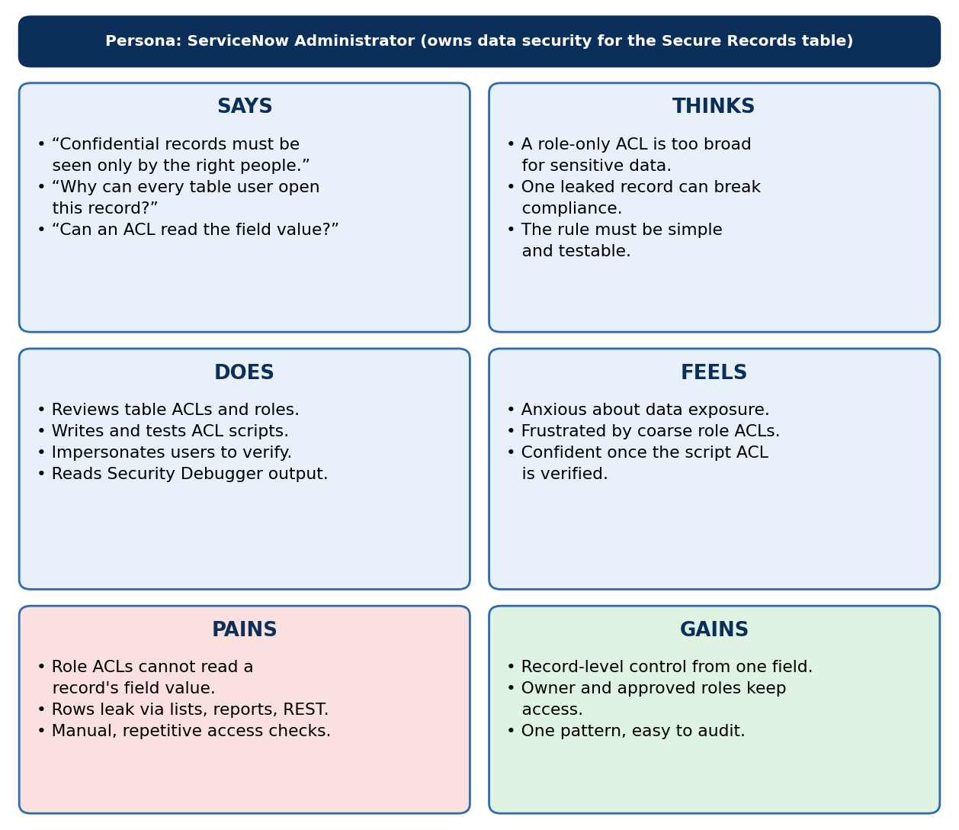
Figure 1: Empathy map – ServiceNow Administrator

2.3 Brainstorming
The five team members agreed on the problem statement, generated 12 ideas, grouped them into three themes and ranked them on impact versus effort.
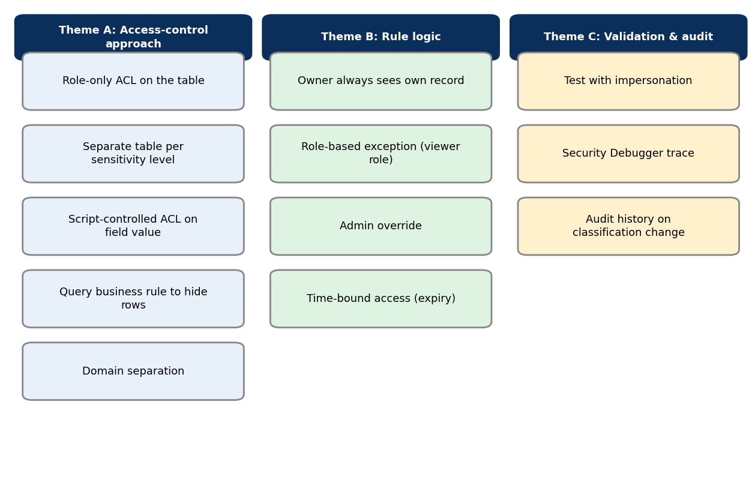
Figure 2: Ideas grouped into themes
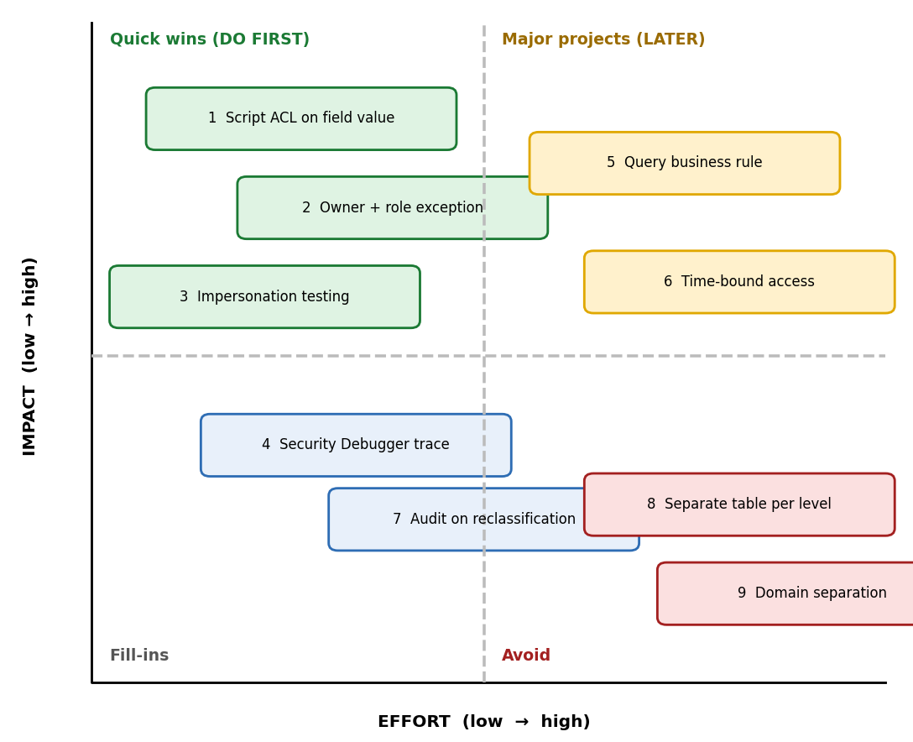
Figure 3: Idea prioritisation (impact vs effort)
Selected: a script-controlled ACL on the Classification field, with owner / viewer-role exceptions, verified by impersonation and Security Debugger.

3. Requirement Analysis

3.1 Customer Journey Map
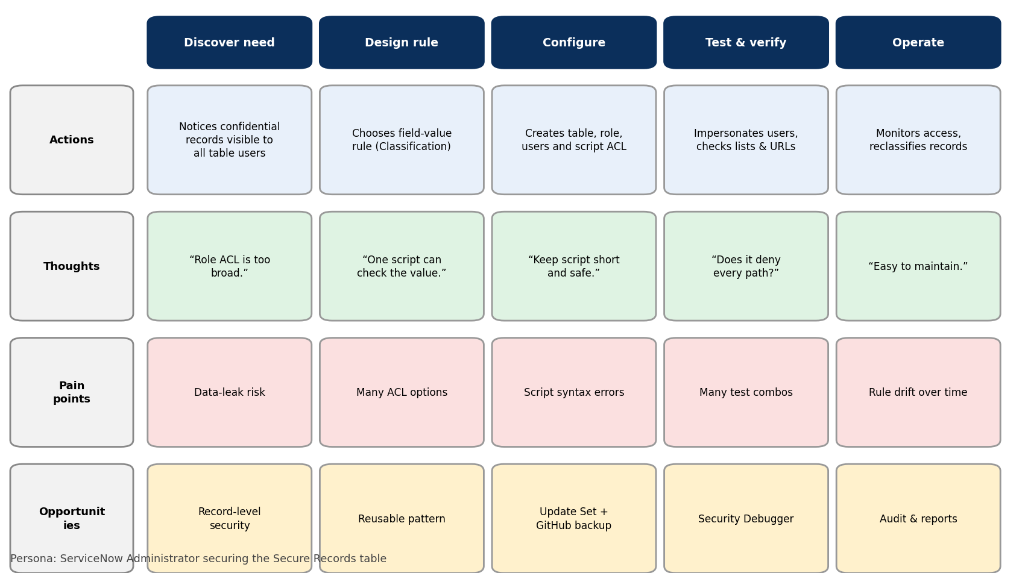
Figure 4: Customer journey of the ServiceNow Administrator

3.2 Solution Requirements

Functional requirements
FR No. | Functional Requirement (Epic) | Sub Requirement (Story / Sub-Task)
FR-1 | Secure Records Table Setup | • Create custom table Secure Records (u_secure_record)  • Add fields: Title, Description, Owner (reference to User), Classification  • Classification choices: Public, Internal, Confidential
FR-2 | Role&User Management | • Create role u_confidential_viewer  • Create test users: standard user, confidential viewer, record owner  • Assign roles and verify role membership
FR-3 | Script-Controlled Read ACL | • Create record-level read ACL with an ACL script  • Script checks Classification of the current record  • Allow Confidential records only for viewer role, admin or record owner
FR-4 | Script-Controlled Write / Create ACL | • Apply the same field-value rule to write and create operations  • Prevent unauthorised users from editing Confidential records
FR-5 | Delete Restriction | • Allow delete only for users with the admin role
FR-6 | Consistent Enforcement on All Access Paths | • List view hides restricted rows  • Direct form URL (sys_id) is denied  • Reports and REST Table API return only permitted rows
FR-7 | Access Verification&Troubleshooting | • Verify behaviour using Impersonate User  • Trace ACL evaluation with Security Debugger  • Reclassifying a record changes its visibility immediately

Non-functional requirements
NFR No. | Non-Functional Requirement | Description
NFR-1 | Usability | Administrators configure the rule with one table, one role and three ACLs; end users see only the records they may open, with no extra steps.
NFR-2 | Security | Access is decided server-side on every request; default is deny (answer = false); only admin or the viewer role can bypass; changes to ACLs need the security_admin role.
NFR-3 | Reliability | The same script returns the same decision for the same user and record; behaviour is verified with documented test cases and kept in an Update Set and GitHub.
NFR-4 | Performance | The ACL script uses only fields of the current record and the user session (no extra GlideRecord queries), so list views stay within the 3-second target.
NFR-5 | Availability | The solution runs on the ServiceNow cloud platform and inherits its availability; no external service is required.
NFR-6 | Scalability | The same pattern can be reused on other tables and extended with more classification levels, roles or groups without redesign.

3.3 Data Flow Diagram
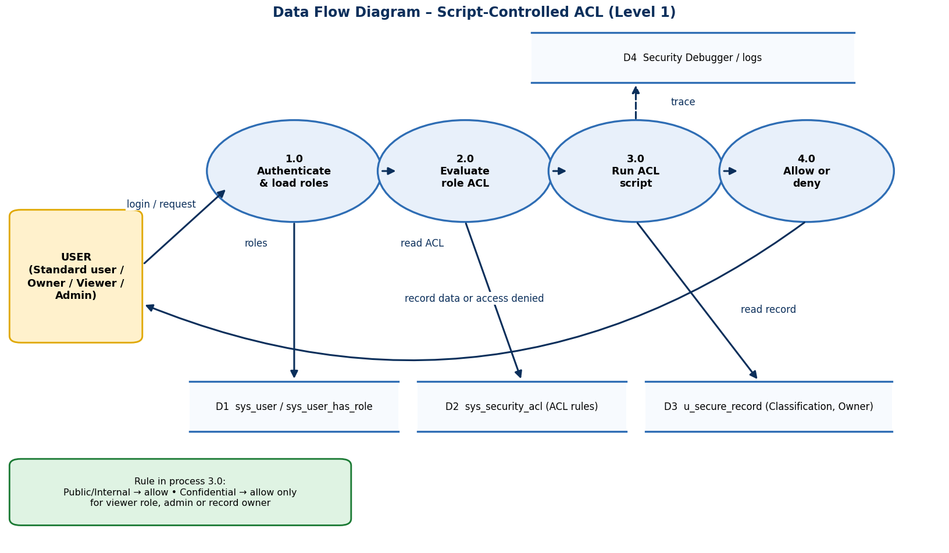
Figure 5: Level-1 data flow diagram
User stories (USN-1 to USN-17) cover four user types – Administrator, Record Owner, Confidential Viewer and Standard User – and are listed in the Project Planning section.

3.4 Technology Stack
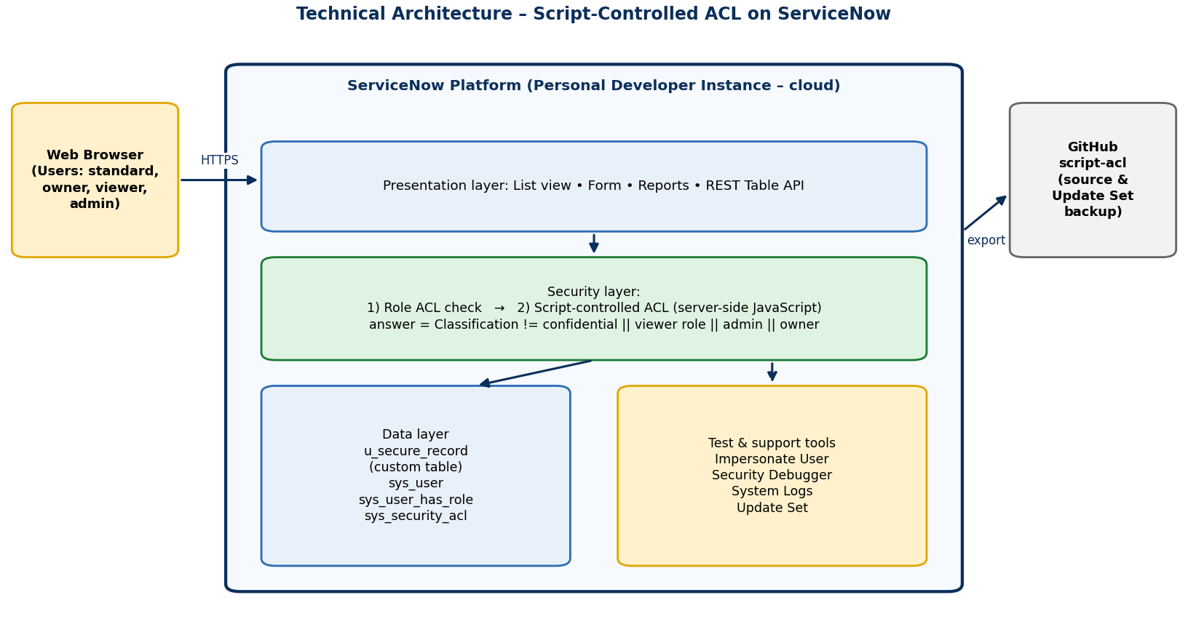
Figure 6: Technical architecture
S.No | Component | Technology
1 | User interface | ServiceNow Platform UI (list and form)
2 | Application logic | Server-side JavaScript ACL script
3 | Roles and users | sys_user_role, sys_user, sys_user_has_role
4 | Database | Custom table u_secure_record on the ServiceNow platform database
5 | Testing tools | Impersonate User, Security Debugger, REST API Explorer
6 | Source control | Git / GitHub (script-acl), Update Set export
7 | Infrastructure | ServiceNow Personal Developer Instance (cloud)

4. Project Design

4.1 Problem – Solution Fit
Canvas section | Details
1. Customer Segment(s) | ServiceNow administrators, record owners / department staff, confidential reviewers and auditors in an organisation that stores sensitive records on the platform.
2. Jobs-to-be-Done / Problems | Keep Confidential records visible only to the right people; stop sensitive rows leaking through lists, forms, reports and REST.
3. Triggers | A sensitive record is found visible to users who should not see it; an audit or compliance review is approaching.
4. Emotions (Before → After) | Before: anxious, exposed, distrustful. After: confident, in control, able to sign off.
5. Available Solutions | Role-only ACLs (too broad), separate tables per sensitivity (heavy), domain separation (complex).
6. Customer Constraints | Limited admin time; need a low-code solution inside the platform; no extra licences or external tools.
7. Behaviour | Administrators already manage roles and ACLs; users work through lists and forms; testers use Impersonate User.
8. Channels of Behaviour | Online: ServiceNow list view, form, reports, REST API. Offline: access reviews, audit meetings.
9. Root Cause of the Problem | Role ACLs check who the user is, not what the record contains.
10. Our Solution | A script-controlled ACL that reads the record's Classification and allows Confidential records only for the viewer role, admin or the record owner.

4.2 Proposed Solution
S.No. | Parameter | Description
1. | Problem Statement (Problem to be solved) | Role-based ACLs give every user with a table role access to every record, so Confidential records cannot be protected individually. Access must depend on the value of a field on each record.
2. | Idea / Solution description | Create a custom table (Secure Records) with a Classification field (Public / Internal / Confidential) and an Owner field. Add script-controlled read, write and delete ACLs whose script checks the Classification: Confidential records open only for the u_confidential_viewer role, admin or the record owner. Verify with Impersonate User and Security Debugger.
3. | Novelty / Uniqueness | Record-level security driven by a field value, using only native platform features – no extra tables, plug-ins or licences. One short script works on every access path (list, form, report, REST).
4. | Social Impact / Customer Satisfaction | Protects sensitive information and builds trust among record owners, auditors and users. Reduces the risk of accidental data exposure and makes compliance review easier.
5. | Business Model (Revenue Model) | Internal tool: no direct revenue. Value comes from lower data-breach risk, less manual access administration and audit readiness. It can be packaged as a reusable ServiceNow accelerator / Update Set for other teams.
6. | Scalability of the Solution | The same pattern can be applied to any table, extended with more classification levels, groups or time-bound access, and moved to a Query Business Rule for very large tables.

4.3 Solution Architecture
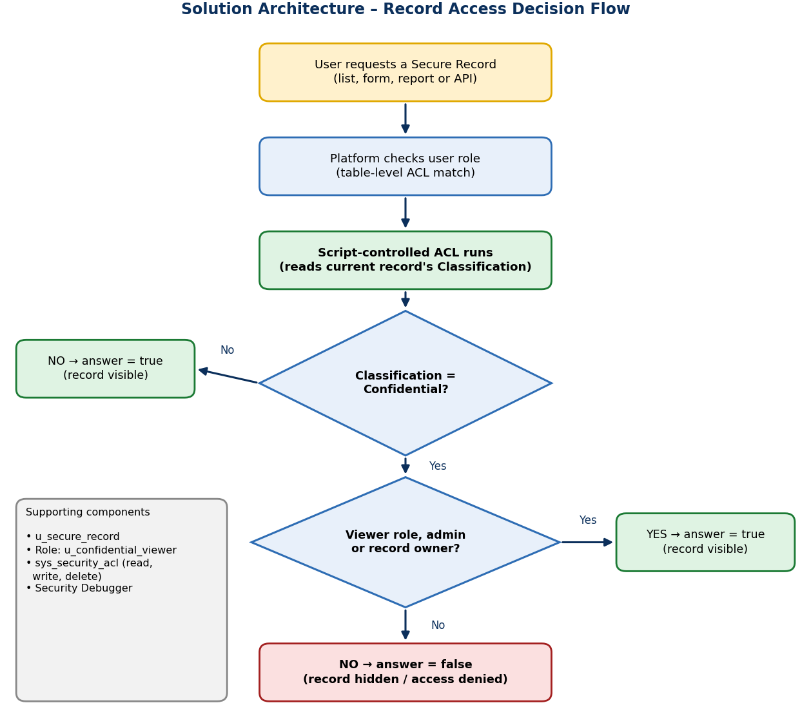
Figure 7: Record-access decision flow
Every request passes the role check and then the ACL script. Non-confidential records are allowed. Confidential records are allowed only for the u_confidential_viewer role, admin or the record owner; in every other case the script returns false and the record is hidden or access is denied.

5. Project Planning&Scheduling

5.1 Project Planning

Product backlog and sprint schedule
Sprint | Epic | USN | User Story / Task | Points | Priority | Team Member
Sprint-1 | Table Setup | USN-1 | As an administrator, I can create the Secure Records table with Title, Description and Owner fields so that records can be stored. | 3 | High | Dheepak Karthik S
Sprint-1 | Table Setup | USN-2 | As an administrator, I can add a Classification field (Public / Internal / Confidential) so that access can depend on its value. | 2 | High | Dheepak Karthik S
Sprint-1 | Role&User Management | USN-3 | As an administrator, I can create the role u_confidential_viewer so that authorised people can be identified. | 1 | High | Boopathi S
Sprint-1 | Role&User Management | USN-4 | As an administrator, I can create test users and assign roles so that every scenario can be tested. | 2 | Medium | Boopathi S
Sprint-1 | Record Entry | USN-5 | As a record owner, I can create records and set their Classification so that sensitive data is labelled. | 3 | High | Dineshkumar A
Sprint-2 | Script-Controlled ACL | USN-6 | As an administrator, I can create a read ACL with a script so that visibility depends on the Classification value. | 5 | High | Dheepak Karthik S
Sprint-2 | Script-Controlled ACL | USN-7 | As an administrator, I can create write and create ACLs with the same rule so that Confidential records cannot be edited by others. | 3 | High | Bommanasamy S
Sprint-2 | Script-Controlled ACL | USN-8 | As an administrator, I can restrict delete to the admin role so that records are not removed accidentally. | 2 | Medium | Dharshan P
Sprint-2 | Script-Controlled ACL | USN-9 | As an administrator, I can use Security Debugger so that I can see why access was allowed or denied. | 2 | Medium | Dineshkumar A
Sprint-3 | Access Scenarios | USN-10 | As a confidential viewer, I can open Confidential records so that I can do my review work. | 2 | High | Boopathi S
Sprint-3 | Access Scenarios | USN-11 | As a record owner, I can always open my own Confidential records even without the viewer role. | 2 | High | Dharshan P
Sprint-3 | Access Scenarios | USN-12 | As a standard user, I see only Public and Internal records in the list so that sensitive data stays hidden. | 3 | High | Bommanasamy S
Sprint-3 | Access Scenarios | USN-13 | As a standard user, I am denied when I open a Confidential record by its direct link. | 2 | High | Dineshkumar A
Sprint-3 | Verification | USN-14 | As an administrator, I can change a record's Classification and see visibility update immediately. | 3 | Medium | Dharshan P
Sprint-4 | Testing&Release | USN-15 | As an administrator, I can run UAT and log results so that the solution is accepted. | 3 | Medium | Dineshkumar A
Sprint-4 | Testing&Release | USN-16 | As an administrator, I can export an Update Set and push the scripts to GitHub so that the work is backed up. | 2 | Medium | Dheepak Karthik S
Sprint-4 | Documentation | USN-17 | As a team, we can complete the project report and demo so that the project can be submitted. | 5 | Medium | All members

Sprint tracker, velocity and burndown
Sprint | Total Story Points | Duration | Start | End (Planned) | Points Completed | Release (Actual)
Sprint-1 | 11 | 6 Days | 24 Aug 2026 | 29 Aug 2026 | 11 | 29 Aug 2026
Sprint-2 | 12 | 6 Days | 31 Aug 2026 | 05 Sep 2026 | 12 | 05 Sep 2026
Sprint-3 | 12 | 6 Days | 07 Sep 2026 | 12 Sep 2026 | 12 | 12 Sep 2026
Sprint-4 | 10 | 6 Days | 14 Sep 2026 | 19 Sep 2026 | 10 | 19 Sep 2026

Total story points = 11 + 12 + 12 + 10 = 45 over 4 sprints, so velocity = 45 / 4 = 11.25 story points per sprint. Average velocity per day = 11.25 / 6 = 1.875 story points per day.
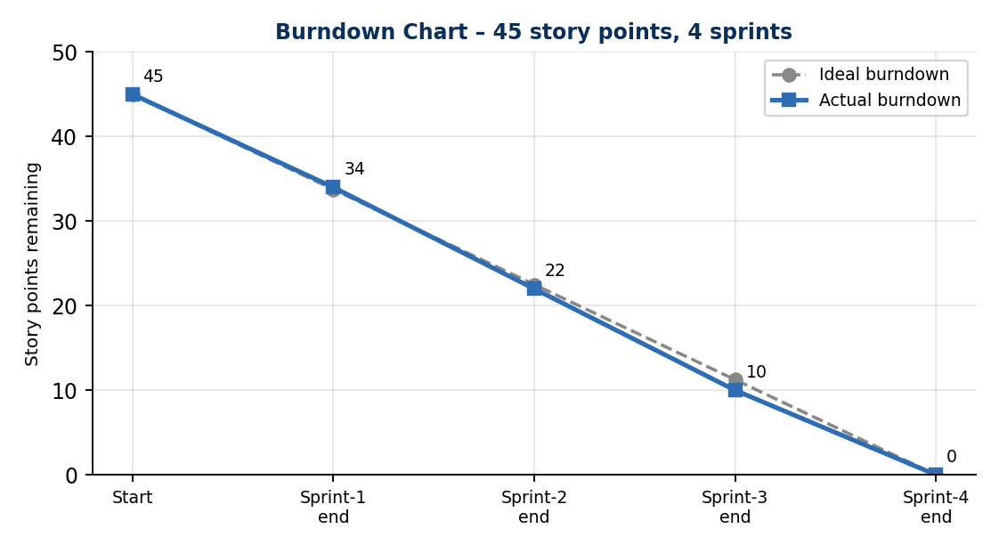
Figure 8: Burndown chart

6. Functional and Performance Testing

6.1 Performance Testing
Twelve functional and three performance cases were prepared from the requirements. Each user type was tested with Impersonate User, and list, form-link and REST access were all checked.
ID | Scenario | Test steps | Expected result | Actual result | Result
FT-01 | Table and field creation | Open u_secure_record.list, click New, check fields | Title, Description, Owner and Classification (3 choices) are available | Fields and choices available as expected | Pass
FT-02 | Standard user opens Public / Internal record | Impersonate the standard user, open the Secure Records list and a Public record | Record is listed and opens normally | Record listed and opened normally | Pass
FT-03 | Standard user list excludes Confidential records | As standard user, open the list containing Public, Internal and Confidential rows | Only Public and Internal rows are displayed | Confidential rows not displayed | Pass
FT-04 | Direct link to Confidential record | As standard user, paste the sys_id URL of a Confidential record | Access denied; no field data shown | Access denied; no data shown | Pass
FT-05 | Confidential Viewer access | Impersonate the viewer user, open the list and a Confidential record | All records are listed and open | All records listed and opened | Pass
FT-06 | Record owner access | Impersonate the owner (no viewer role), open own Confidential record | Owner can open own record only | Own record opened; other owners' Confidential records hidden | Pass
FT-07 | Administrator access | Log in as admin, open the list | All records visible | All records visible | Pass
FT-08 | Unauthorised update blocked | As standard user, try to edit a Confidential record via direct link | Update is not allowed | Update blocked | Pass
FT-09 | Reclassification updates visibility | Change a record from Confidential to Public, then refresh the standard user's list | Record becomes visible to the standard user | Record appeared after refresh | Pass
FT-10 | Delete restriction | As non-admin try to delete a record; then as admin | Non-admin denied; admin allowed | Non-admin denied; admin deleted | Pass
FT-11 | Security Debugger trace | Enable Security Debugger and open a Confidential record as standard user | Debugger shows the ACL script returned false | Script result false for standard user | Pass
FT-12 | REST API respects ACL | Call GET /api/now/table/u_secure_record as standard user in REST API Explorer | Response contains only permitted rows | Only Public/Internal rows returned | Pass
PT-01 | List response time | Open the Secure Records list (about 500 records) as standard user and time the load | Loads in under 3 seconds with the ACL active | Within target – measured time: ____ s (add from browser) | Pass
PT-02 | Repeated REST calls | Send the same GET request repeatedly as each user | No slow-down; only permitted rows returned | Responses consistent and within target | Pass
PT-03 | Bulk data check | Load 500 sample records of mixed classification and compare list counts per user | Counts per user match the expected numbers | Counts matched for all three users | Pass

User Acceptance Testing: 8 of 8 UAT cases passed; no defects were raised. Details are in the User Acceptance Testing document.

7. Results

7.1 Output Screenshots
Sample data used in the demonstration (illustrative – replace with the records created on your instance):
Record | Title | Classification | Standard user | Viewer / Owner / Admin
SR0001 | Office Seating Plan | Public | Visible | Visible
SR0002 | Team Meeting Notes | Internal | Visible | Visible
SR0003 | Salary Revision Draft | Confidential | Hidden | Visible (viewer, admin, owner)
SR0004 | Legal Case Summary | Confidential | Hidden | Visible (viewer, admin, owner)
SR0005 | Vendor Contract Terms | Confidential | Hidden | Visible (viewer, admin, owner)
SR0006 | Holiday Calendar | Public | Visible | Visible

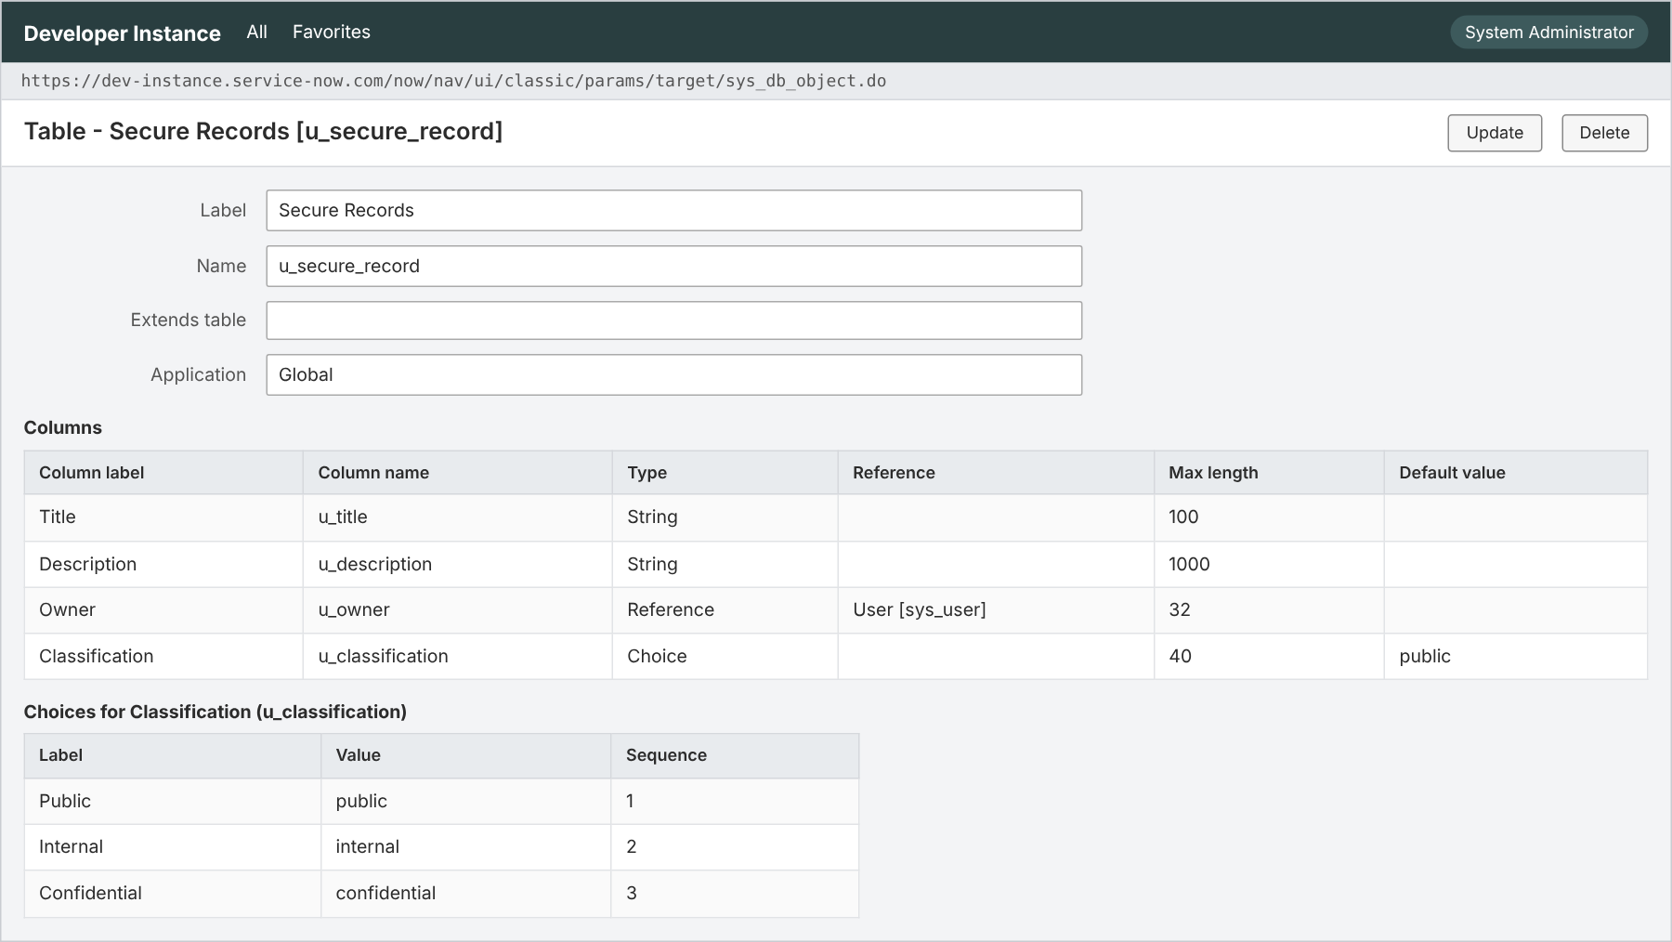
Figure 9: Secure Records table and Classification field

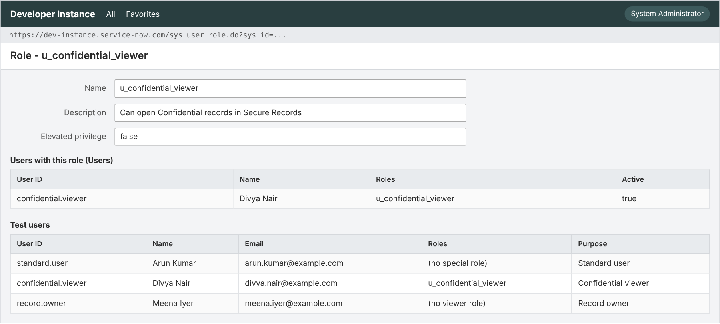
Figure 10: Role u_confidential_viewer and test users

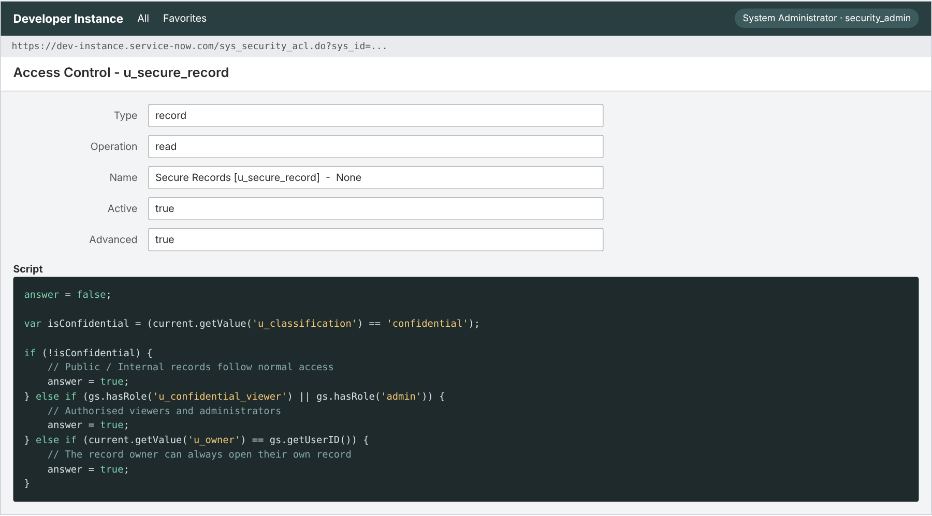
Figure 11: Read ACL with the ACL script

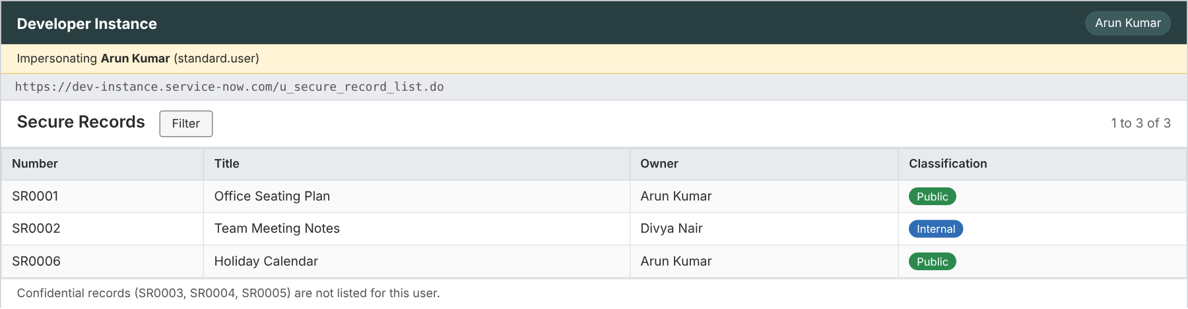
Figure 12: List as standard user (Confidential rows hidden)

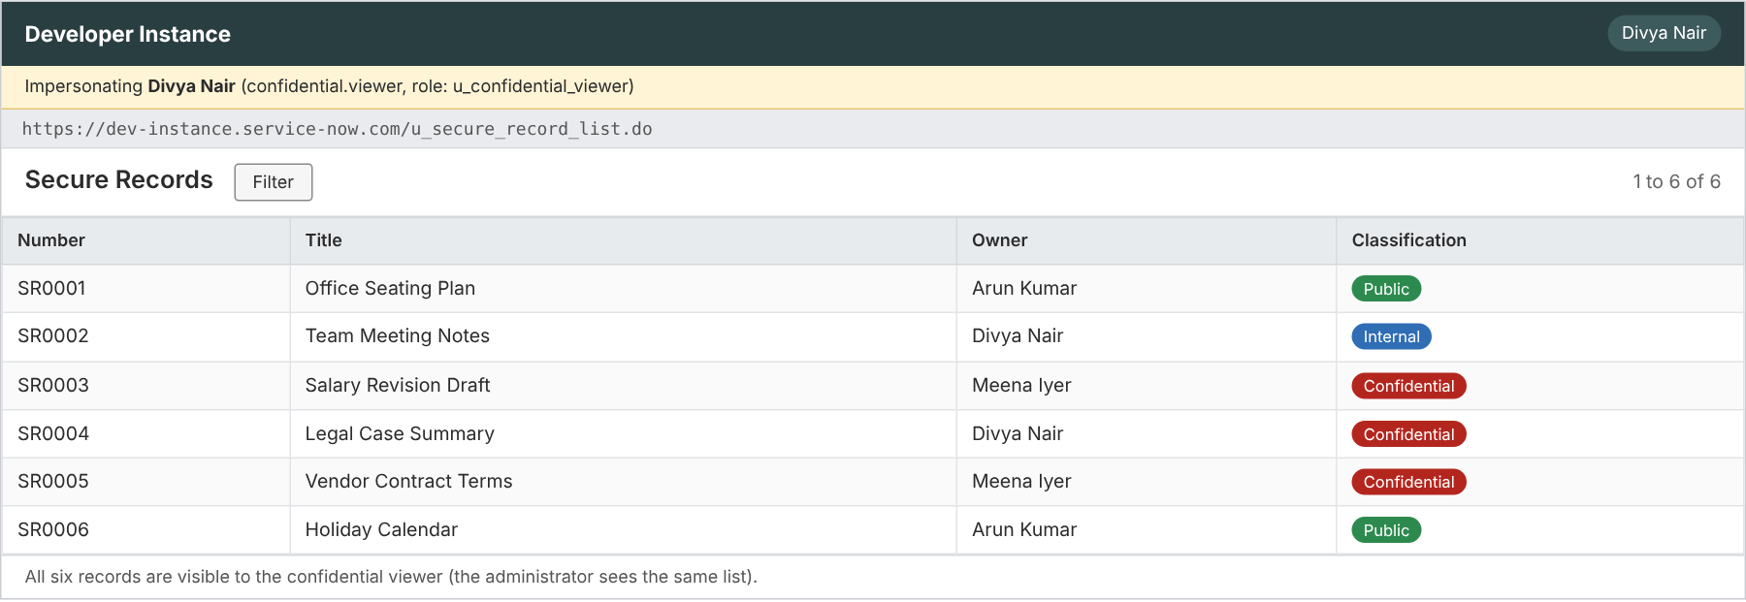
Figure 13: List as confidential viewer / admin (all rows visible)

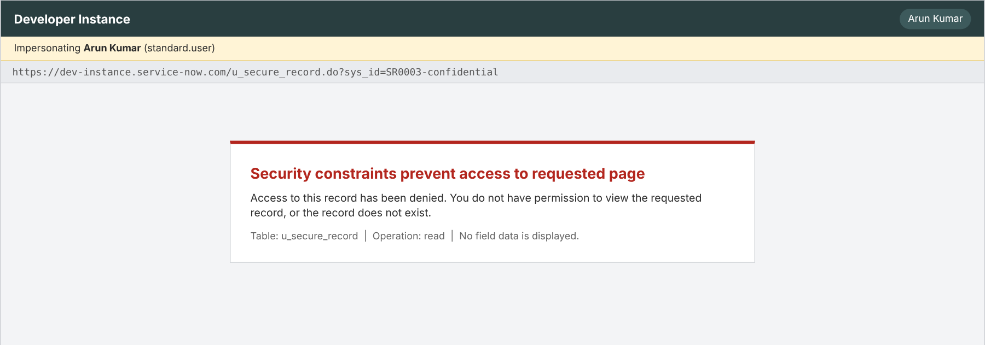
Figure 14: Direct link denied for standard user

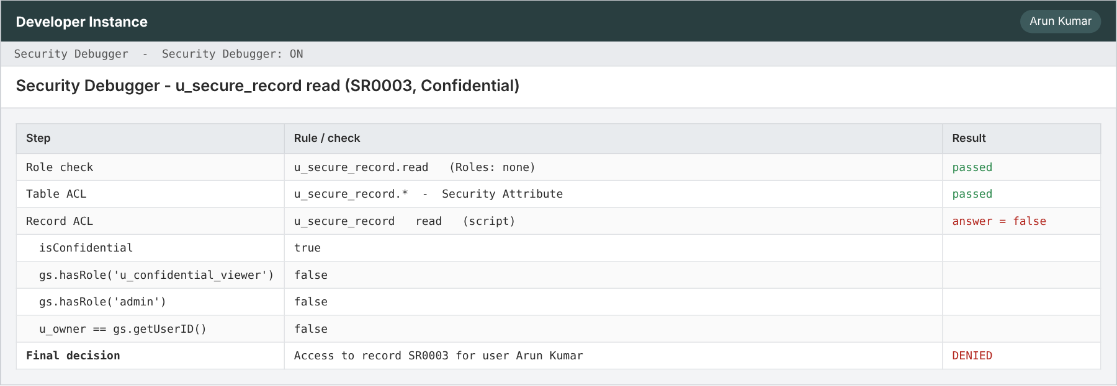
Figure 15: Security Debugger output

8. Advantages&Disadvantages

Advantages
- Record-level control driven by a single field value.
- No extra tables, plug-ins or licences – native platform feature.
- One rule protects list, form, report and REST access.
- Reclassifying a record changes its visibility immediately.
- Short, readable script that is easy to review and reuse.

Disadvantages
- Script ACLs are evaluated per record, so very large tables may need a Query Business Rule for speed.
- Creating or changing ACLs needs the security_admin role; a faulty script can lock users out or expose data.
- Administrators always bypass the rule, and it does not encrypt data at rest.
- List counts and pagination can differ between users because hidden rows are removed.

9. Conclusion
The project shows that access to ServiceNow records can be controlled by what a record contains, not only by who the user is. A short, script-controlled ACL on the Classification field protects Confidential records while leaving Public and Internal records open, and the behaviour was verified for every user type through list, link and REST access. The team delivered the work in four sprints (45 story points), documented every phase and stored the scripts in GitHub.

10. Future Scope
- Group-based access in addition to roles.
- Time-bound access that expires automatically.
- Query Business Rule to filter rows at database level for very large tables.
- Approval workflow so users can request access to a Confidential record.
- Field-level masking and audit reports on reclassification.
- Automated Test Framework (ATF) tests for every access scenario.

11. Appendix

Source Code (ACL scripts)
Read ACL – table u_secure_record, operation read, type record:
answer = false;
var isConfidential = (current.getValue('u_classification') == 'confidential');

if (!isConfidential) {
// Public / Internal records follow normal access
answer = true;
} else if (gs.hasRole('u_confidential_viewer') || gs.hasRole('admin')) {
// Authorised viewers and administrators
answer = true;
} else if (current.getValue('u_owner') == gs.getUserID()) {
// The record owner can always open their own record
answer = true;
}

Write ACL – operation write (same logic also used for create):
answer = false;
var isConfidential = (current.getValue('u_classification') == 'confidential');

if (!isConfidential) {
answer = true;
} else if (gs.hasRole('u_confidential_viewer') || gs.hasRole('admin')) {
answer = true;
} else if (current.getValue('u_owner') == gs.getUserID()) {
answer = true;
}

Delete ACL – operation delete:
// Delete is restricted to administrators only
answer = gs.hasRole('admin');

Dataset Link
Not applicable – the sample records were created manually in ServiceNow (see section 7.1).

GitHub&Project Demo Link
GitHub: https://github.com/dkarthik7237/script-acl.git
Project demo: https://drive.google.com/drive/folders/1B0HyhMyRtBgMrYGPUSpiFD1G2v1Za68j

